BAESI Name _______________________________

Sea Level Rise in the Bay Area

Supplies
Topo maps (Mt. View, San Leandro, & San Francisco North 7.5’ quads)
Transparency film
Overhead markers
Paper clips
Internet access: “Pacific Institute Sea Level Rise Maps”
Internet access: “Going UP: Sea Level Rise in San Francisco Bay Area” (KQED Quest)

A. Sea Level Change and Ancient Coastlines

adapted from Windows to the Universe (www.windows2universe.org)

Before we do this exercise, it is important to understand the concept of topographic maps and their contour lines.

Topographic maps use contour lines to portray the shape and elevation of the land. As stated by the USGS: “Topographic maps render the 3-dimensional ups and downs of the terraine on a 2-dimensional surface.” Topographic maps provide notations about natural and manmade features, such as mountains, rivers, roads, airports, and major buildings.

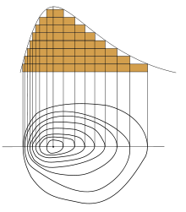
In a topographic map, contour line joins points of equal elevation above (or below) a given level, such as mean sea level. Contour lines do not cross each other – you cannot have two different elevations at a single point. The contour interval of a topographic map is the difference in elevation between successive contour lines. While a topographic map typically displays elevation above a given level (i.e. mean sea level), it may also display bathymetric contours – elevations below a given level. These are marked with negative values.
Mt. Baldy = 220’
mean sea level = 0’

Contour lines on other kinds of maps can represent values others than relative elevation. On an ocean salinity map, the contour lines will join points of equal salinity (again, without crossing).

On the image to the right, what is the contour interval?

Which contour lines represent bathymetry?

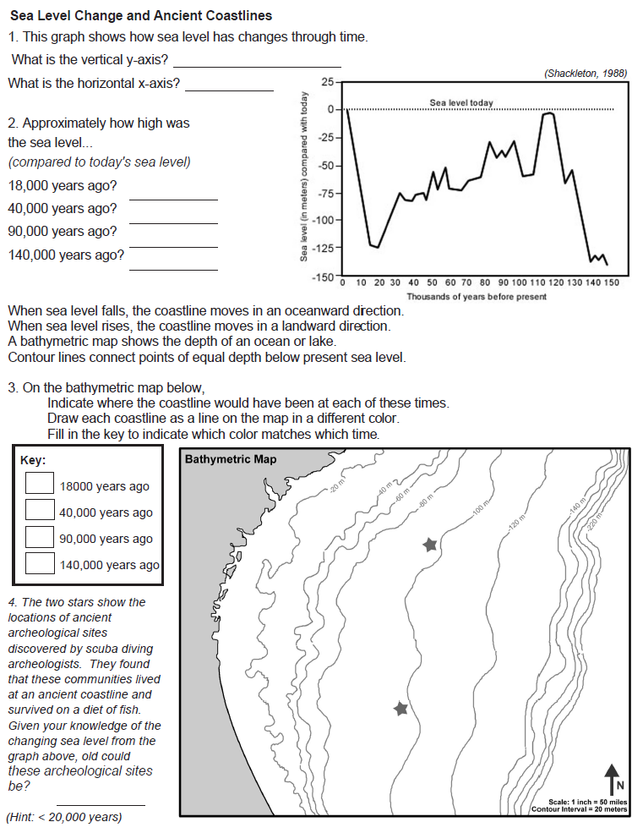

B. Predicted Sea Level Rise in the Bay Area

We’ve talked about several sea-level rise scenarios. Here are two projections, both based on a review of scientific research. Why the difference between the 2007 and 2010 projections for sea level change by 2100? Scientists have gathered data since 2007 that show polar and mountain glaciers are melting more rapidly than previously understood.

2007 IPCC report Up to 0.59 m (2 feet) by year 2100
2010 US National Research Council Up to 2 m (6.6 feet) by year 2100
2007 IPCC report Up to 6 m (20 feet) over next centuries

1. Choose one of the topographic maps at your table and fill in the following table.

 | San Francisco North | Mountain View | San Leandro
Year it was made
Contour interval
Lowest elevation contour on your map? (0 feet? 5 feet? 10 feet?)
Pick a part of the map that you are curious about – in terms of how future sea level rise might affect infrastructure or land. Use paper clips to attach transparency sheet(s) overlain on your chosen part of the map. Use the overhead markers to trace the following contours: 0 feet, 5 feet (10 feet for the SF North map), and 20 feet.
If sea level rises 5 feet (10 feet for the SF North map), how far inland will the shoreline move? (use the scale in feet)
If sea level rises 20 feet, how far inland will the shoreline move?
How many sewage disposal sites would be flooded at 5 (or 10 feet for SF North)?
How many sewage disposal sites are flooded at 20 ft?
Other interesting sites that would be flooded at 5 feet (or 10 feet for SF North)
Other interesting sites that would be flooded at 20 ft

C. Video (13 mins). “Going UP: Sea Level Rise in San Francisco Bay” (KQED Quest)

Prior to viewing:

1. What do you know about global warming and sea-level rise?

2. How do you think rising sea levels will affect you and your community?

During viewing:

1. What will the San Francisco Bay Area be like if marsh sedimentation can’t keep up with rising sea level?

2. What kinds of changes could rising sea level cause in the future?

3. What are some Bay Area neighborhoods already doing to combat rising sea level?

4. Other impressions of the video:

D. Pacific Institute Coastal Risk Maps

The Pacific Institute has generated maps of the San Francisco Bay Area that depict possible sea-level inundation and coastal erosion related to predicted sea level rise over the next century. A 100+ page report provides details for their methods and findings.

http://www.pacinst.org/reports/sea_level_rise/maps/index.htm

1. Click on “Google Maps” and zoom in on the San Francisco Bay Area.

2. Under “Hazard Zones,” turn on “Area at risk from a 100-year coastal flood event.”
This map depicts regional risk of sea level rise based on the NCAR CCSM Climate Model SRES A2 Scenario. In other words: 1.4 meters (4.6 feet) mean sea level rise by 2100, from a study by Cayan et al. (2009) which re-ran IPCC models with outputs from six external climate studies. This assumes some mitigation of fossil fuel use but follows the findings of recent studies that sea level is responding to global warming faster than the 0.2 – 0.6 m rise by 2100 predicted by the IPCC.

A. Which part of the Bay Area is expected to see the furthest inland inundation?

B. Which part of the Bay Area is expected to see the least inundation?

2. Under “Infrastructure at risk, click on “Wastewater treatment plants.”

A. How many treatment plants are at risk?

3. Under “Infrastructure at risk, click on “EPA-regulated sites.”

A. How many EPA sites would be inundated?

4. Other observations from this map database:

